Bahria University,

Karachi Campus



LAB EXPERIMENT NO.04

LIST OF TASKS

|  |  |
| --- | --- |
| TASK NO | OBJECTIVE |
|  |
| 1 | 1. **Connect 4 switches A, B, C and D, all switches must be password protected (encrypted password) and apply the following configuration, show network topology and configuration in your lab task.** 2. Switch B, C, D must be connected to switch A 3. Switch B with VLAN name Faculty & Students having 5 logical ports each 4. Switch C with VLAN name Management having 3 logical ports 5. Switch D with VLAN name SRC & NCMPR having 3 logical ports each 6. Choose network IP from Class B for LAN like 172.16.X.X for hosts to test your LAN network |
|  |  |
|  |  |
|  |  |
|  |  |
|  |  |
|  |  |

Submitted On:

Date: 26/10/20

1. **Connect 4 switches A, B, C and D, all switches must be password protected (encrypted password) and apply the following configuration, show network topology and configuration in your lab task.**

**Switch A:**

  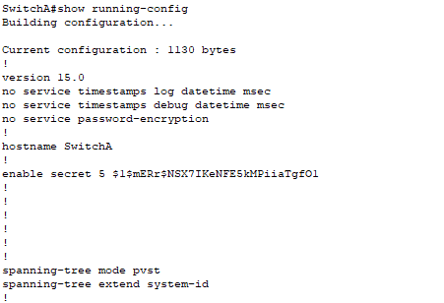 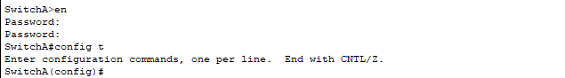

**Switch B:**

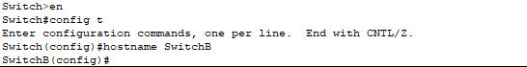 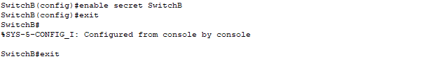 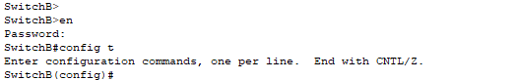 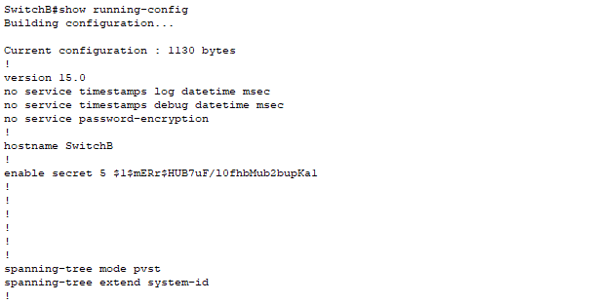

**Switch C:**

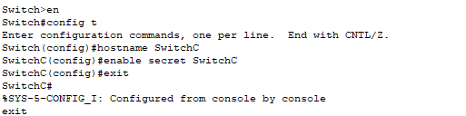 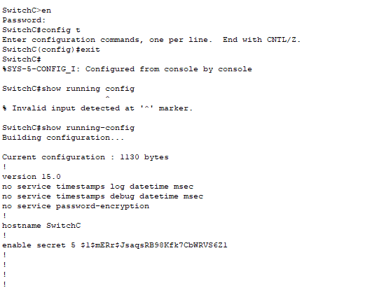

**Switch D:**

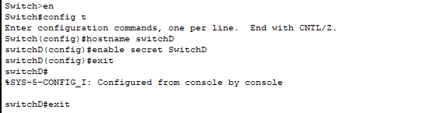 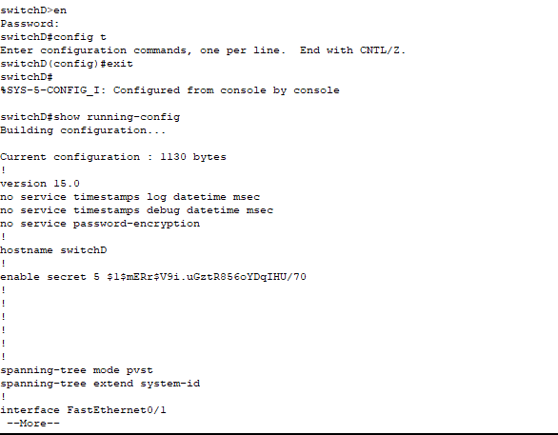

1. Switch B, C, D must be connected to switch A

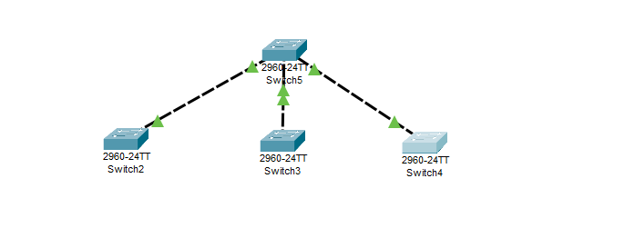

1. Switch B with VLAN name Faculty & Students having 5 logical ports each

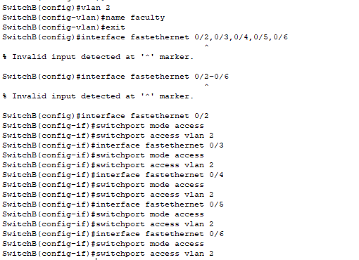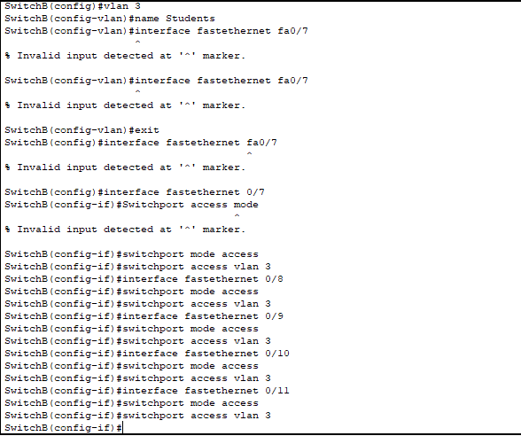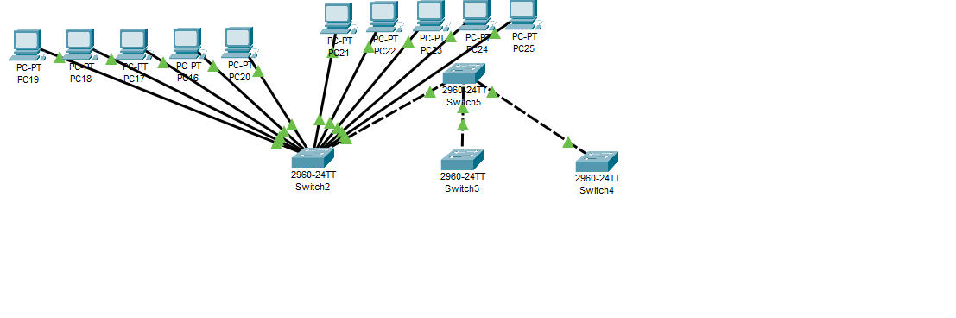

1. Switch C with VLAN name Management having 3 logical ports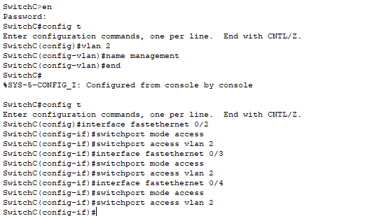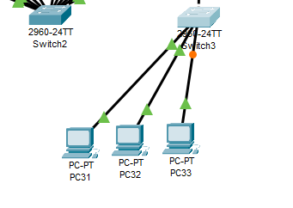
2. Switch D with VLAN name SRC & NCMPR having 3 logical ports each

**SRC:** 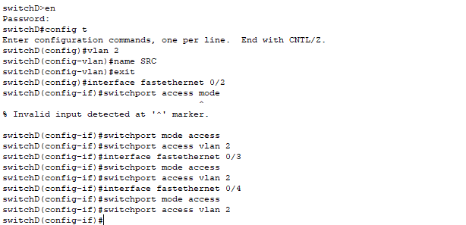

**NCMPR:**

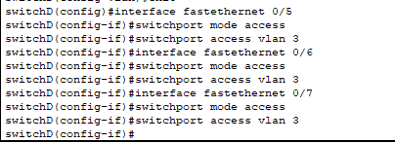

1. Choose network IP from Class B for LAN like 172.16.X.X for hosts to test your LAN network

**Faculty:**



**Student:**



**Management:**



**SRC:**



**NCMPR:**

